**Experiment No.1**

**Aim:** Edit/Compile/run a program to display the statements on two different lines.

**Program A:**

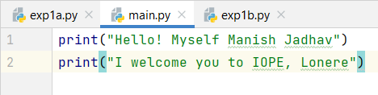

**Output:**

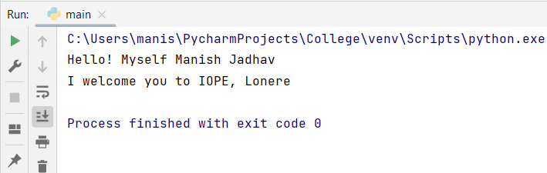

**Program B:**

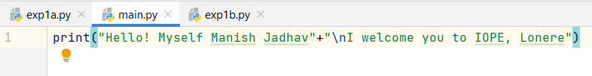

**Output:**



**Program C:**

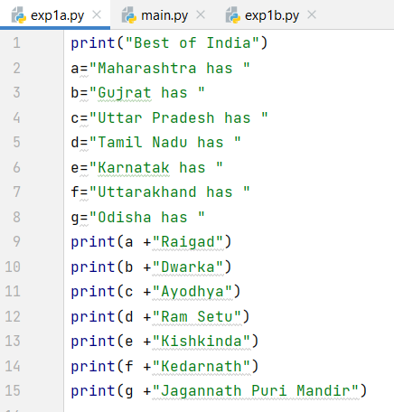

**Output:**

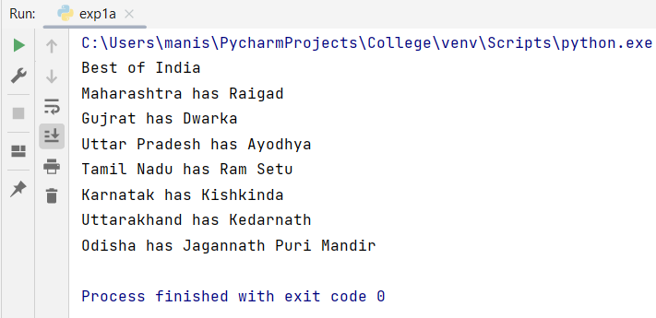

**Program D:**

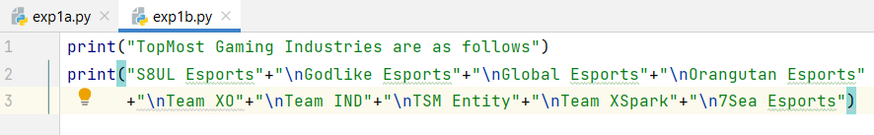

**Output:**

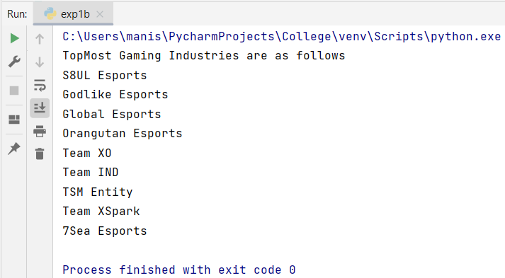

|  |  |  |  |
| --- | --- | --- | --- |
| **Writeup & Oral**  **(4)** | **Practical Performance**  **(4)** | **Attendance**  **(2)** | **Total**  **(10)** |
|  |  |  |  |